Form 2: Literature Documents

**1. Team No:** 20

**2. Project Title:** Blockchain Technology in Agriculture Product Supply C**hain.**

**3. Problem Statement:**

The agricultural product supply chain is plagued by challenges such as lack of transparency,traceability issues, and inefficient record-keeping. These issues lead to difficulties in verifying the authenticity of products, delays in identifying and resolving supply chain disruptions, and increased chances of fraud. Traditional systems fail to provide a comprehensive solution to these problems, necessitating the exploration of innovative technologies like blockchain.

**4.Problem Illustration:**

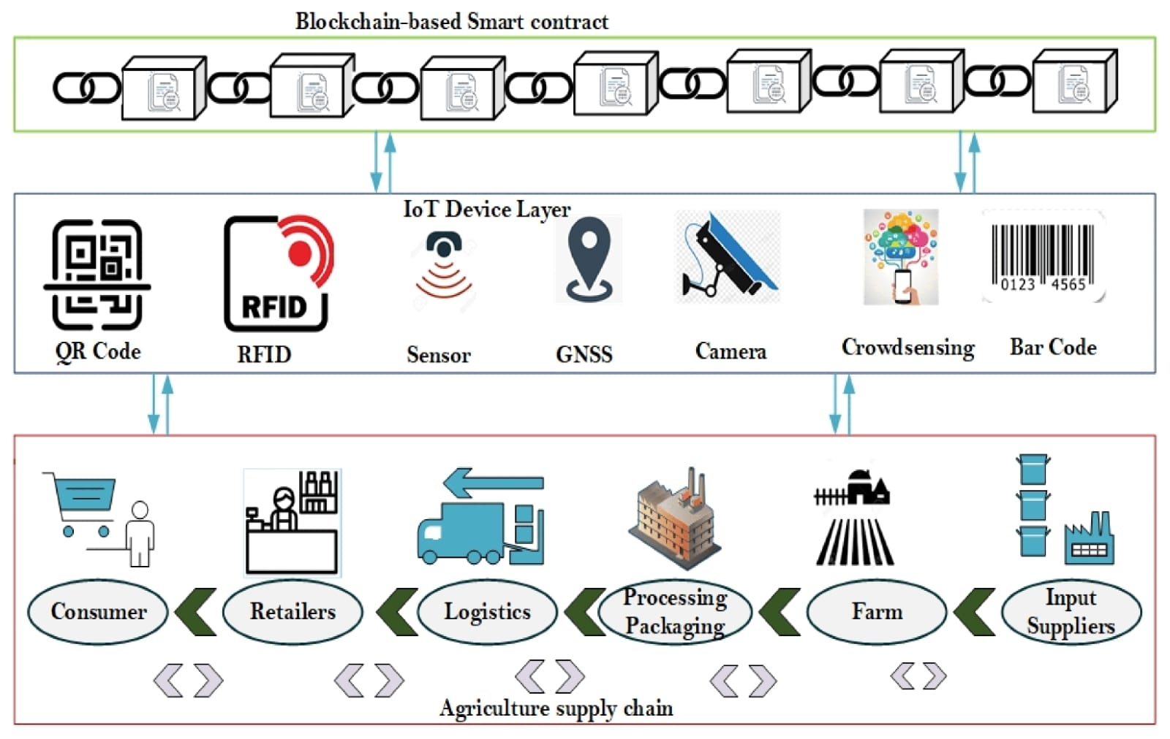

**5. Concept Tree**

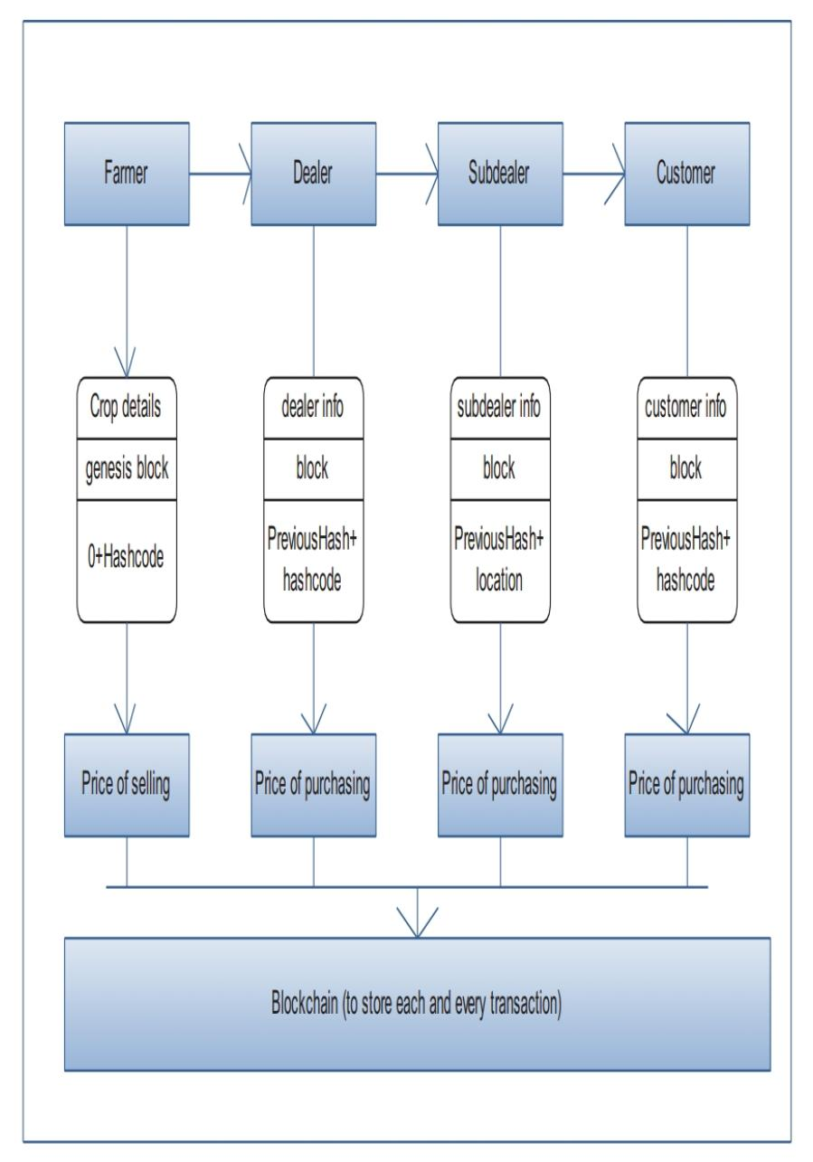

**6.** **Comparison of Existing Strategies for Problem solve**

|  |  |  |  |
| --- | --- | --- | --- |
| Sl. No | Strategies | Advantages | Disadvantages |
| 1 | Data Security and Integrity | IOT devices may be vulnerable to security breaches,posing risks to data integrity and privacy | While blockchain ensures the security and integrity of on-chain data, there may be challenges in securing off-chain components. Metadata, communication channels, or external systems connected to the blockchain may still be vulnerable to traditional security threats. |
| 2 | Decentralization and Trust | Eliminates the need for a central authority,fostering trust among parties in data exchange | Achieving decentralization and maintaining trust through consensus mechanisms can lead to scalability challenges. As the number of participants or nodes in the decentralized network increases, the consensus process becomes more resource-intensive and time-consuming. |
| 3 | Immutable Record Keeping | Ensures that once data is recorded,it cannot be altered,providing a tamper-resistant and auditable record | Once data is recorded on the blockchain and becomes immutable, any errors, inaccuracies, or fraudulent entries are permanent. |

**7. Comparison of Existing Method from selected Strategies**

|  |  |  |  |  |
| --- | --- | --- | --- | --- |
| Sl. No |  | Strategies | Advantages | Disadvantages |
| 1 |  | Fraud Reduction | Reduces fraud by ensuring accurate records of the product journey. | Requires consistent participation from all entities in the supply chain. |
| 2 |  | Real-time Tracking: | Enables real-time tracking of product movement, enhancing supply chain visibility.  . | Relies on the adoption of tracking technologies by all parties. |
| 3 |  | Transparency and Trust: | Builds consumer trust by providing a transparent and traceable supply chain. | Implementation may require collaboration among various |
| 4 |  | Decentralized Execution:  . | Executes predefined rules without the need for intermediaries. | Immutability can make correcting errors challenging. |
| 5 |  | Supply Chain Transparency: | Enhances transparency in the supply chain by recording quality-related information | Dependence on accurate entry of quality-related data. |

**8. References:**

[1] M. M. Aung and Y. S. Chang, ``Traceability in a food

supply chain: Safety and quality perspectives,'' Food Control,

vol. 39, pp. 172_184, May 2014.

[2] T. Bosona and G. Gebresenbet, ``Food traceability as an

integral part of logistics management in food and agricultural

supply chain,'' Food Control, vol. 33, no. 2, pp. 32_48, 2013.

[3] J. Hobbs, ``Liability and traceability in agri-food supply

chains,'' in Quan- tifying the Agri-Food Supply Chain.

Springer, 2006, pp. 87_102.

[4] D. Mao, Z. Hao, F. Wang, and H. Li, ``Novel automatic

food trading system using consortium blockchain,'' Arabian J.

Sci. Eng., vol. 44, no. 4, pp. 3439_3455, Apr. 2018.

[5] L. U. Opara and F. Mazaud, ``Food traceability from _eld

to plate,'' Outlook Agricult., vol. 30, no. 2, pp. 239_247, 2001.

[6]. Li, Q., Wang, M., Gu, W.: Computer Vision Based

Systemfor Apple Surface Defect Detection. Computers and

Electronics in Agriculture 36, page 215-223 .

[7]. Kim, M.S., Lefcourt, A.M., Chen, Y.R., Tao,

Y.:Automated Detection of Fecal Contamination of Apples

Based on Multispectral Fluorescence Image Fusion. Journal of

food engineering 71, page 85-91 .

[8]. Dubey, S.R.: Automatic Recognition of Fruits and

Vegetables and Detection of Fruit Diseases. Proceedings of the International Conference on Artificial Intelligence and Smart Systems (ICAIS-2021)

IEEE Xplore Part Number: CFP21OAB-ART; ISBN: 978-1-7281-9537-7

[9]. Dubey, S.R., Jalal, A.S.: Adapted Approach for Fruit

Disease Identification using Images. International Journal of

Computer Vision and Image Processing 2(3), page 51 – 65.

[10]. Kleynen, O., Leemans, V., Destain, M.F.: Development

of a Multi-Spectral Vision System for the Detection of Defects

on Apples. Journal of Food Engineering 69, page 41-49 .

[11]. Leemans, V., Magein, H., Destain, M.F.: Defect

Segmentation on ‗Golden Delicious‘ Apples by using Color

Machine Vision. Computers and Electronics in Agriculture 20,

page 117-130 .

[12]. Dubey, S.R., Jalal, A.S.: Detection and Classification of

Apple Fruit Diseases using Complete Local Binary Patterns.

In Proceedings of the 3rd International Conference on

Computer and Communication Technology, page 346-351,

Allahabad, India .

[13]. Dubey, S.R., Jalal, A.S.: Fruit disease recognition using

improved sum and difference histogram from images.

International Journal of Applied Pattern Recognition 1(2),

page 199-220 .

[14]. Choi, Y.H., Tapias, E.C., Kim, H.K., Lefeber, A.W.M.,

Erkelens, C., Verhoeven, J.T.J., Brzin, J., Zel, J., Verpoorte,

R.: Metabolic Discrimination of Catharanthus Roseus Leaves

Infected by Phytoplasma using 1H-NMR Spectroscopy and

Multivariate Data Analysis. Plant Physiology 135, page 2398-

2410 .

**Signature Team Members Signature Supervisor**

Mr.K.Sadanandam

**1.** CH.Thanmai [20EG105609]

**2.** A.Devika [20EG105639]

**3.** M.Harshith Varma [20eg105712]

**4**. N.Sujeeth Kumar [20EG105717]